Report by: 1409046  
Role: Level Design & Artist liaison

Game Version: Latest – with Menus  
Date Reported: 06/05/2016

QA Status: Passed

Severity: Major

Priority: Moderate

Test Introduction:

The purpose of this test was to check that the buttons on the win and death state work correctly. To test this, I ran the ship into one of the obstacles then reloaded the game and got to the end to test winning buttons.

Expected outcome:

The replay button would re-load the current level, the main menu button would take you to the main menu.

Actual outcome:

When the death state canvas was displayed the buttons were not interactive, they flashed as if they were clickable but the links did not work, the same for the win state.

Screenshot of the bug:

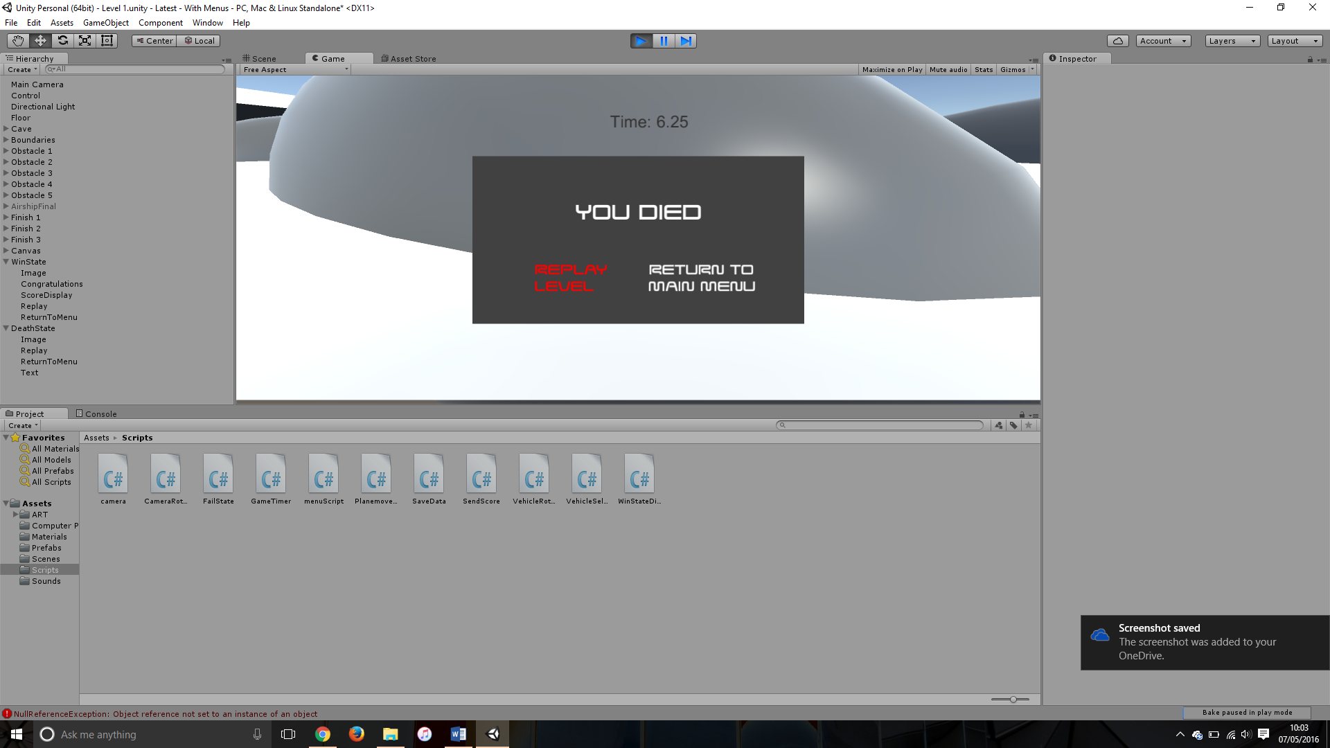

Image showing the button being clicked but no change in the screen.

Potential cause:

A potential cause for this bug could be that the code is pointing to the incorrect level, or one that doesn’t exist

Another cause for this bug could be that when the code was moved into a new script to keep the project ‘cleaner’ the old links became redundant.

Suggested Fix:

To fix this bug I had to place the correct script on the canvas then add the canvas to the ‘OnClick’ function and call the corresponding methods for replay and main menu.